THE MiCA SCAM GOLD RUSH
How Europe’s biggest crypto regulatory overhaul created the perfect social engineering lure
INVESTIGATION • UPDATED AUGUST 8, 2026
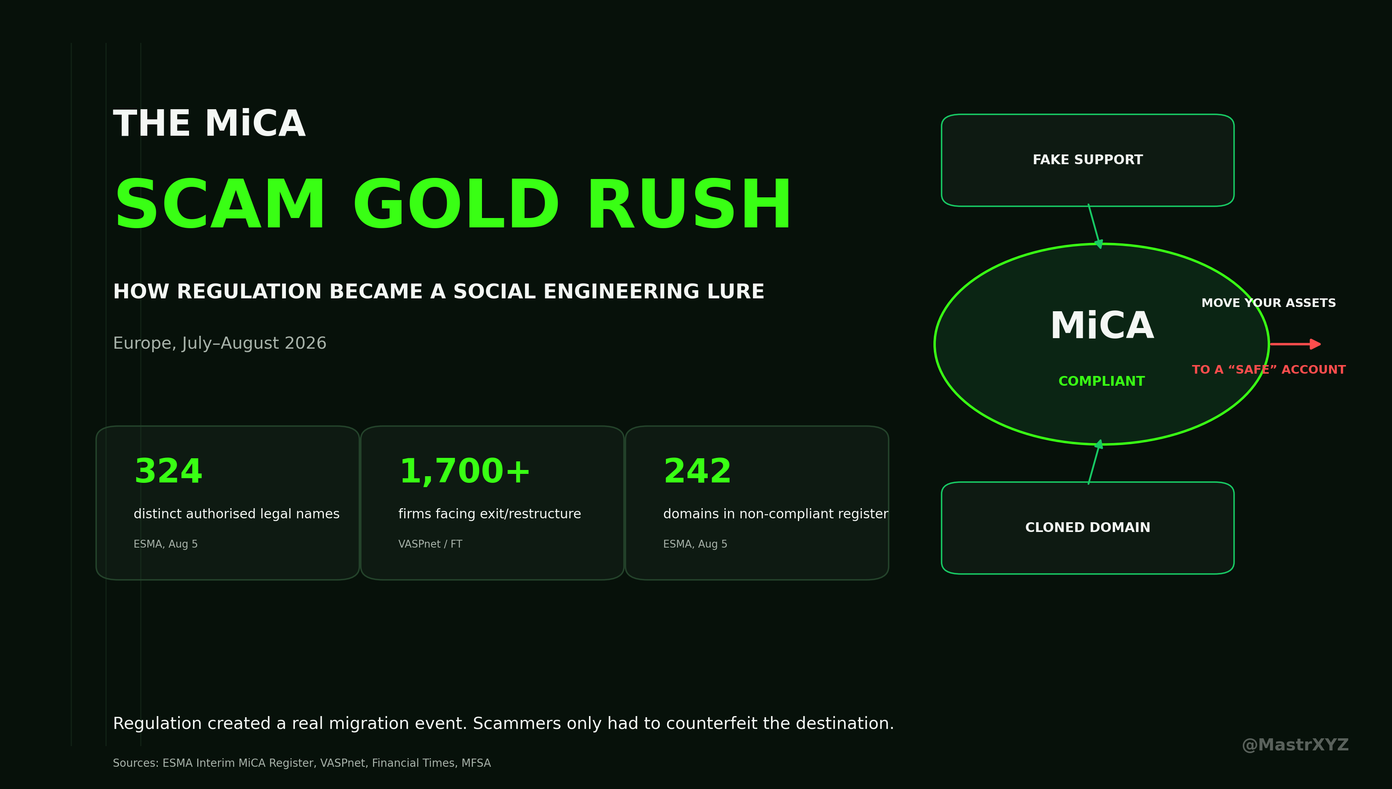
Regulation created a real migration event. Scammers only had to counterfeit the destination.
KEY NUMBERS
324  authorised legal names | 1,700+  exit/restructure estimate | 242  non-compliant domains | $17B  2025 scam/fraud estimate

The regulatory transition scammers did not have to invent
MiCA was supposed to make Europe’s crypto market easier to understand: clear licensing rules, defined responsibilities, stronger consumer protection and fewer companies operating in regulatory grey zones.
Instead, the final transition has also created one of the best phishing narratives scammers could have asked for.
Since July 1, millions of European crypto users have suddenly had to work out whether their exchange is still allowed to serve them, whether the company behind the brand actually holds a MiCA authorisation, whether assets need to be moved, whether an account has to be migrated and whether an email warning about an expiring licence is legitimate.
Scammers did not have to invent the story. European regulation gave them a real one.
On August 7, Malta’s Financial Services Authority explicitly warned about an increase in crypto-related impersonation scams during the MiCA transition. According to the regulator, criminals are pretending to be crypto companies, financial authorities and European institutions. Victims are contacted through email, phone calls, messaging apps, social media and fake websites.
The central trick is simple: the victim is told that their current crypto provider is no longer authorised under MiCA. They are then instructed to move their assets to a supposedly compliant, protected or regulated account. The account belongs to the scammers.
This is not a hypothetical attack model anymore. France’s AMF and the Dutch AFM have both highlighted the vulnerability around users searching for authorised providers after the transition. The Financial Times reported that the AMF had encountered cases in which fraudsters impersonated either the regulator itself or crypto exchanges and directed users towards fake accounts or websites.
MiCA has therefore created something beyond a licensing regime. It has created a massive identity-verification problem.
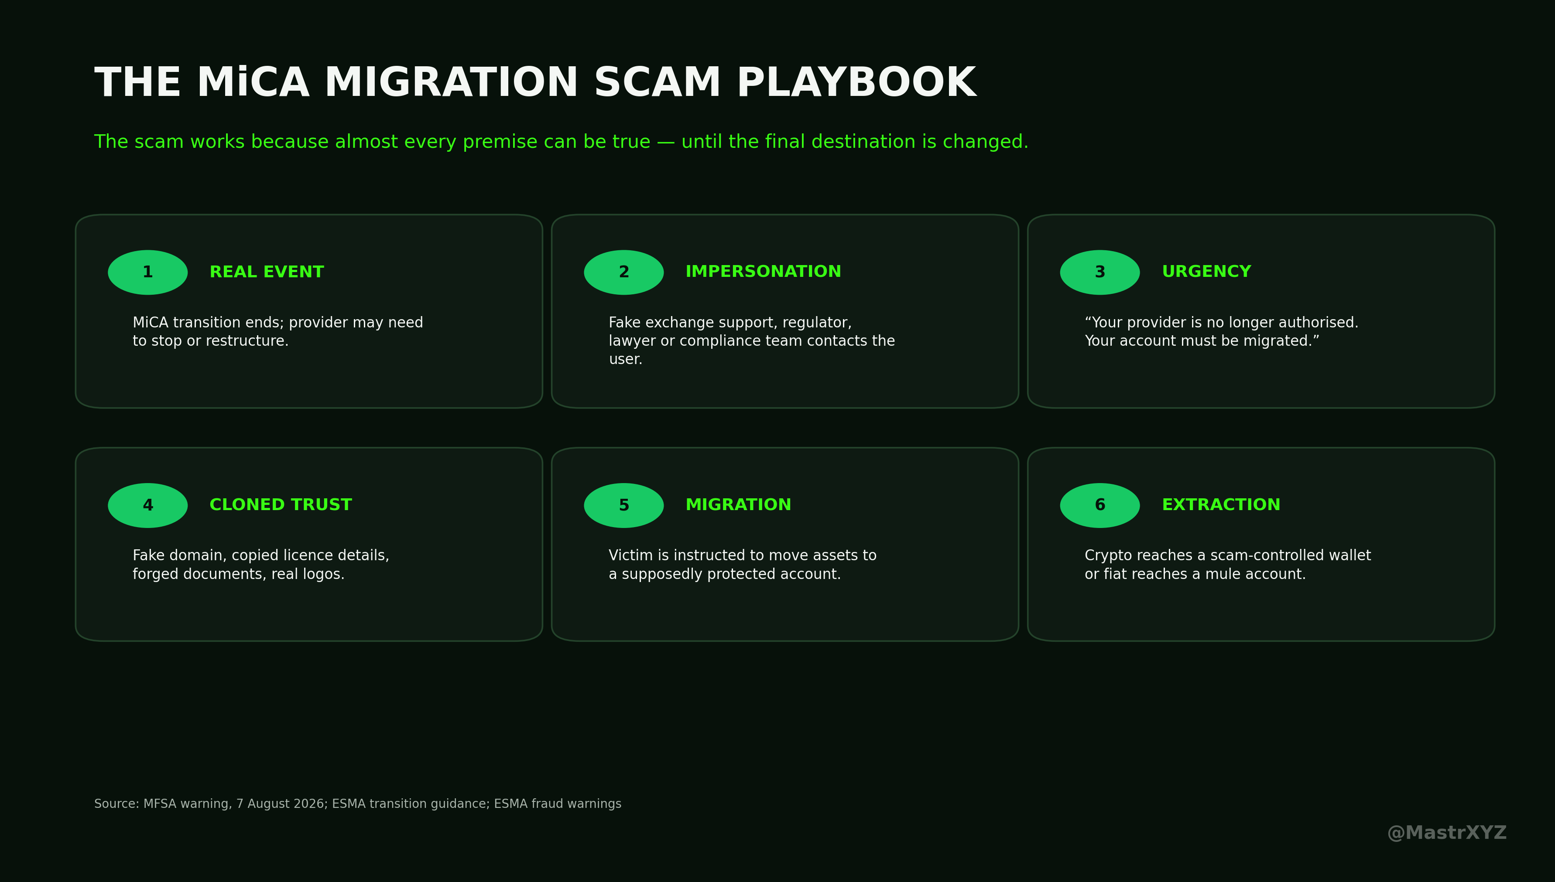
Data graphic • @MastrXYZ

The 1,700 company figure is real — but it is widely misunderstood
One number circulating around this story is especially important, but it is easy to misuse.
The Financial Times reported that 323 crypto companies had secured licences while VASPnet estimated that more than 1,700 unlicensed companies would have to disappear from the market or change their structure. That does not mean Europe identified 1,700 scams. It does not even mean 1,700 companies were formally classified by ESMA as non-compliant entities. Those are different categories.
VASPnet describes the structural change in even larger terms. Before MiCA, the European market reached a peak of approximately 3,781 registered VASPs. By July 14, 2026, VASPnet counted 289 MiCA-authorised CASPs. Among 78 major centralised exchanges it reviewed, only 20 held at least one MiCA authorisation. Around 55% of authorised CASPs were concentrated in only 5 countries.
VASPnet correctly warns that old national VASP registrations and new MiCA CASP authorisations are not directly comparable. But the numbers still show the scale of the regulatory consolidation.
The official numbers have continued moving quickly. ESMA updates its central register weekly. In the version dated August 5, 2026, my review of the official CSV dataset found 329 CASP records representing 324 distinct legal names.
Germany accounted for the largest group with 69 distinct names, followed by France with 35, the Netherlands with 29, Cyprus with 25 and Malta with 22. Spain had 15, Luxembourg 13, Liechtenstein and Ireland 12 each, Austria and Czechia 11 each, Latvia 10 and Italy 9.
This distinction matters. Companies without a MiCA authorisation, companies forced to restructure or leave a market, and companies formally listed as non-compliant are not the same thing. Anyone combining those categories into one giant scam list may produce a dramatic number, but not an honest investigation.
The separate ESMA register for non-compliant entities providing crypto-asset services looks very different. My review of the August 5 dataset found 167 records, 162 distinct entity names and 242 distinct domains. Of those 167 records, 165 came from Italy, 1 from the Netherlands and 1 from Slovakia.
That does not mean 99% of Europe’s MiCA problem is Italian. It tells us something about enforcement too. CONSOB is using its website-blocking and enforcement powers aggressively, and those cases are fed into the European register. The dataset therefore reflects enforcement intensity as well as the geographical distribution of unauthorised activity.
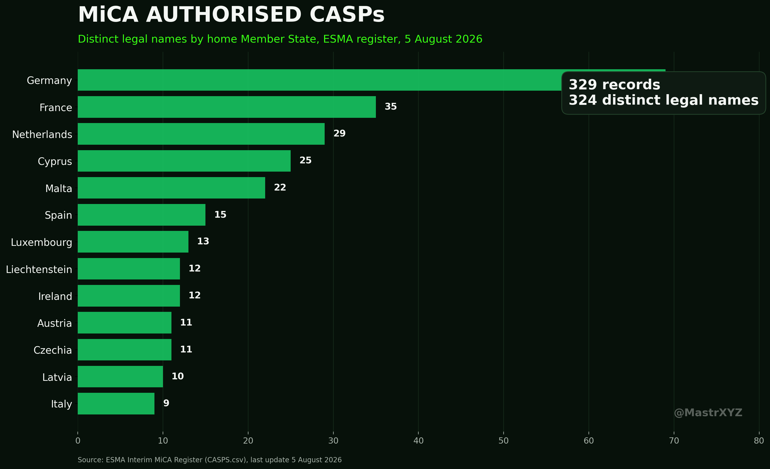
Data graphic • @MastrXYZ

July 1 created an almost perfect migration scam
The real vulnerability sits inside MiCA’s transition mechanism.
Under Article 143, businesses already providing crypto services under national law before December 30, 2024 could, depending on the Member State, continue under transitional arrangements until they received a MiCA decision or until July 1, 2026 at the latest. After that point, providers without the necessary authorisation had to stop providing the relevant services.
From a regulatory perspective, that is reasonable. From the perspective of a social engineer, it is almost perfect.
ESMA expected unauthorised firms to stop onboarding new EU customers, stop active marketing and solicitation, and arrange an orderly wind-down that protected existing clients. That can involve closing positions, transferring relationships or moving assets. France’s AMF likewise warned investors that not every existing provider would remain authorised after July 1.
Now imagine the scam message: Your exchange is no longer MiCA compliant. Your account must be migrated. Your assets have to be transferred before the regulatory deadline. Use this secure account. Click here.
Two years ago, an experienced crypto user might have treated that message as obviously suspicious. In July 2026, a legitimate provider could plausibly be sending something that sounds dangerously similar.
That is why artificial urgency matters. Legitimate companies are contacting users about regulation at the exact moment criminals are copying the same language. The criminal no longer has to explain why the victim suddenly needs to move money. Regulation already did that part for him.

When the regulator itself becomes the bait
ESMA has dealt with criminals abusing its identity for years. Its fraud guidance warns that scammers use ESMA’s name, logo, supposed employees, forged documents and cloned websites. Contact attempts can arrive through email, telephone, SMS and social media.
Some criminals claim they can recover lost investments. Others pretend ESMA is conducting an investigation and needs information, fees or payments from the victim. Under MiCA, that old scam suddenly becomes more credible because the regulator is now genuinely central to whether a crypto provider can operate across Europe.
ESMA tells users to verify the exact communication channel. Official ESMA emails end in @esma.europa.eu. ESMA is based in Paris and has no branch offices elsewhere. A website displaying an ESMA logo, regulatory wording or copied documents proves nothing.
France has faced the same impersonation problem for years, and Germany provides a very recent example of how easily a legitimate identity can be cloned. On August 7, 2026, BaFin warned about onlinesparen.expert, onlinesparenglobal.com and ai-wallet.org. Financial and crypto-asset services were being advertised using another company’s identity. BaFin explicitly stated that the offers did not originate from Tradias GmbH and described the case as identity theft.
There is no evidence that this specific BaFin case belongs to the same MiCA scam campaign. But the infrastructure is almost exactly what a MiCA impersonation operation needs: a real company, a stolen identity, professional-looking domains, financial products and a victim persuaded that the counterparty is regulated.

242 domains show how disposable the infrastructure has become
The ESMA non-compliance register becomes particularly interesting when you stop looking only at company names and start looking at domains.
On July 8, 2026, CONSOB took action under MiCA against Reversal Investment Group via reversalsimgroup.com and Kortex via kortexbit.com. The corresponding resolutions were 24074 and 24075. These are documented cases of unauthorised crypto-asset services. That does not automatically prove criminal fraud, and that distinction matters.
Other entries reveal how disposable the infrastructure can be. Cervo Rendisco is associated in the ESMA dataset with 8 domains: cervorendisco.com, cervo-rendisco.com, cervo-rendisco.net, cervo-rendisco.site, cervorendisco-ai.com, cervorendiscoia.com, cervo-rendiscoia.com and cervorendisco-it.click.
Flandenzo appears with 4 domains: flandenzo.com, flandenzoia.net, flandenzo-it.org and flandenzoia.com. Corona Fondenza appears with coronafondenza.com and corona-fondenza.net.
Portafica is linked to 15 domains in the ESMA dataset, including marketpulsehubx.top, italinsightpro.top, marketpulserf.info, meridianad.info, borealhub.pro, clariseline.top and mindsparklety.info. Patrimera appears alongside bircholtless.top, econmilanozone88.pro and romatrendix.xyz. Aziovale appears alongside fintrendtrackerq.info, zenithad.top and marketflowgridz.top.
The pattern deserves attention: multiple interchangeable domains, disposable-sounding financial brands, heavy use of .top, .pro, .info and .xyz, and AI variants appearing beside traditional financial branding.
But this is where an investigation needs discipline. Similar naming structures do not prove common ownership. To establish that several brands belong to one operation, you would want overlaps in hosting, registrars, TLS certificate history, analytics identifiers, email servers, phone numbers, payment processors, wallet addresses or repeated transaction destinations. Without those links, the similarities are leads. They are not attribution.
Outside Italy, the ESMA register includes MEXC Global under the Netherlands, with the stated reason that MEXC Global provided crypto-asset services in the Netherlands without the required MiCAR licence. The entry is dated September 16, 2025. The single Slovak entry is LWEX, associated with lwex.com, following a decision dated February 10, 2025.
Again, regulatory non-compliance does not automatically mean criminal fraud. That distinction has to survive even when the companies involved are unpopular.
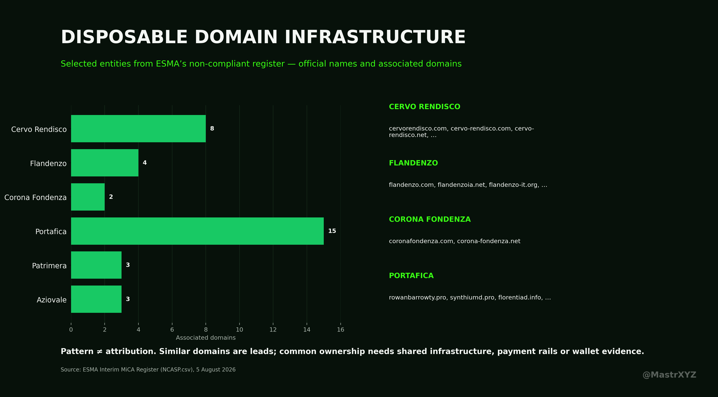
Data graphic • @MastrXYZ

Where are the Telegram groups and wallets?
This is where many crypto investigations start inventing certainty that does not exist.
After reviewing public warnings and documentation from ESMA, AMF, AFM, MFSA, CONSOB and BaFin, as well as available blockchain-intelligence reporting, I could not find a verified Telegram handle or publicly disclosed wallet cluster that a regulator has definitively attributed to the current MiCA impersonation wave.
That does not mean these channels do not exist. The MFSA explicitly confirms that scammers are using messaging applications and social media. ESMA also lists social media, email, phone and SMS among the methods used by impersonators. What regulators have not yet provided publicly are enough specific handles, wallet addresses or downstream transaction clusters to connect these campaigns onchain.
That distinction matters. Taking a Telegram channel from another investment scam, finding an unrelated wallet and attaching both to a MiCA story would make the article look more forensic. It would also make it less true.
What can be reconstructed is the payment flow at the procedural level. A user has an account with an old or potentially unauthorised provider. Somebody claiming to represent the exchange or a regulator contacts them. A genuine regulatory change is used as the explanation. The victim is moved to a cloned website, fake support channel or private conversation. Forged documents, fake compliance procedures or supposed migration instructions follow. Eventually the user is told to transfer cryptocurrency to an address controlled by the scammer, or fiat to a controlled bank or mule account.
Without the final destination addresses, the public onchain investigation stops there. Anything further would currently be speculation.

The market behind these attacks is already enormous
The MiCA scams are arriving inside a fraud industry that was already expanding rapidly.
Chainalysis estimates that around $17 billion was stolen globally through crypto scams and fraud in 2025. The average individual scam payment increased by 253% to $2,764. More importantly for this story, impersonation scams were the fastest-growing major scam category, increasing by more than 1,400% year over year.
AI is making the economics even better for criminals. According to Chainalysis, AI-enabled scam operations averaged around $3.2 million in revenue per operation and were roughly 4.5 times more profitable than traditional scam operations in its dataset.
Deepfakes, face swaps, automated communication and increasingly capable language models are reducing the cost of impersonating companies, government officials and support personnel at scale.
MiCA therefore did not arrive in a market full of a few amateur phishers. It arrived in a global fraud economy that has already industrialised impersonation. And that industry has acquired an excellent new phrase: MiCA compliance.
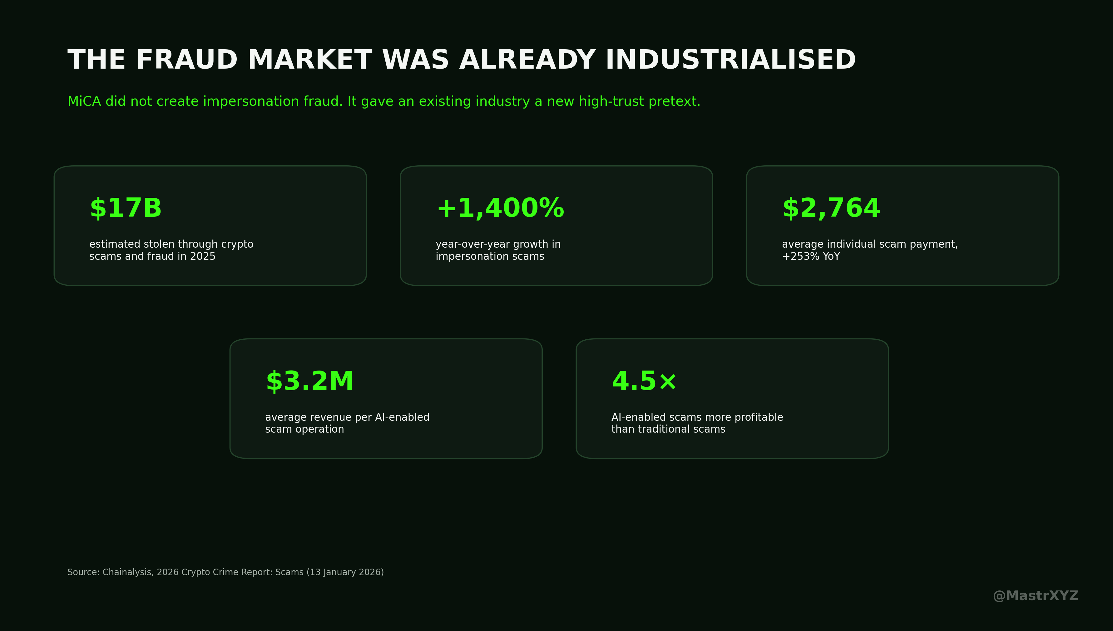
Data graphic • @MastrXYZ

The most dangerous confusion is between a brand and the licensed legal entity
There is another weakness that deserves far more attention. Consumers think in brands. Regulators authorise legal entities.
People say things like “Coinbase is MiCA regulated” or “Exchange X has a MiCA licence.” Legally, the situation can be more complicated. A particular European company inside an international group may hold the authorisation. Other companies, products, websites or services associated with the same global brand are not automatically the same legal entity.
That is why users should check the actual authorised entity in the ESMA register. The database contains legal names, LEIs, competent authorities, websites, services and authorisation information.
For social engineers, that complexity is useful. A scammer does not need to fabricate an entire company. He can copy a legitimate brand, the real legal company name, real licence information and a regulator’s logo, then change only the domain, email address, wallet destination or support account.
At that point, the statement “We are MiCA compliant” starts functioning like a fake verification badge. It creates trust while most users never check which legal entity actually holds the authorisation and whether the exact domain they are communicating with belongs to that entity.

Europe’s regulatory paradox
MiCA itself is not the problem. A unified licensing framework, public registers and clearer accountability are useful security mechanisms.
The problem appears when a massive regulatory migration collides with poor consumer understanding, complicated corporate structures and an already industrialised scam economy.
July 1 created a hard regulatory deadline, a huge customer migration event, a legitimate reason for companies to contact users about accounts and assets, a commercial race between authorised providers to acquire displaced customers, and a credible explanation for why someone might suddenly be asked to move crypto.
Scammers are exploiting the same event.
There are therefore 2 gold rushes happening at once. On the legitimate side, authorised CASPs are competing for customers leaving providers that can no longer operate in Europe under their previous structure. On the criminal side, scammers are copying the same language, the same companies and increasingly the regulators themselves.
They no longer need to convince someone that a ridiculous investment will return 1,000%. They only need to convince them that their current exchange will no longer be legal tomorrow. Psychologically, that is a much stronger weapon.
The best phishing campaigns are rarely built entirely from lies. They contain enough truth to make the single fraudulent instruction believable. MiCA currently provides scammers with a lot of truth. July 1 really was a regulatory deadline. Old national registrations really did stop being enough in many cases. Some companies really did have to restructure or leave. Customers really can be contacted about migrations. ESMA really does maintain a central register. Regulators really are warning consumers about unauthorised providers.
The criminal only needs to add 1 fake domain and 1 wallet address.
On August 7, the MFSA effectively described the playbook in public: stolen identities of exchanges and regulators, forged documents, fake websites, messaging apps, claims that licences have expired, supposed safe accounts and artificial urgency.
The next stage of this investigation depends on technical artefacts that regulators have so far published only sparingly: the actual fake domains, Telegram and messaging identities, wallet addresses, bank accounts, phone numbers, hosting clusters, registrar relationships and the movement of stolen assets after victims transfer them.
Until those records become available, there is no reason to invent a criminal organisation or attach unrelated wallet clusters to the story. What is already documented is serious enough.
Europe has just completed the most significant forced restructuring of its crypto market to date. Hundreds of firms now hold MiCA authorisations. Far more companies have had to change their structure, leave parts of the market or wind down services. At exactly the same time, impersonation fraud is growing at four-digit rates, and regulators are already seeing criminals weaponise the transition by pretending to be exchanges and authorities and instructing users to move their assets.
MiCA was designed to create a new layer of trust. Scammers have already learned how to counterfeit it.
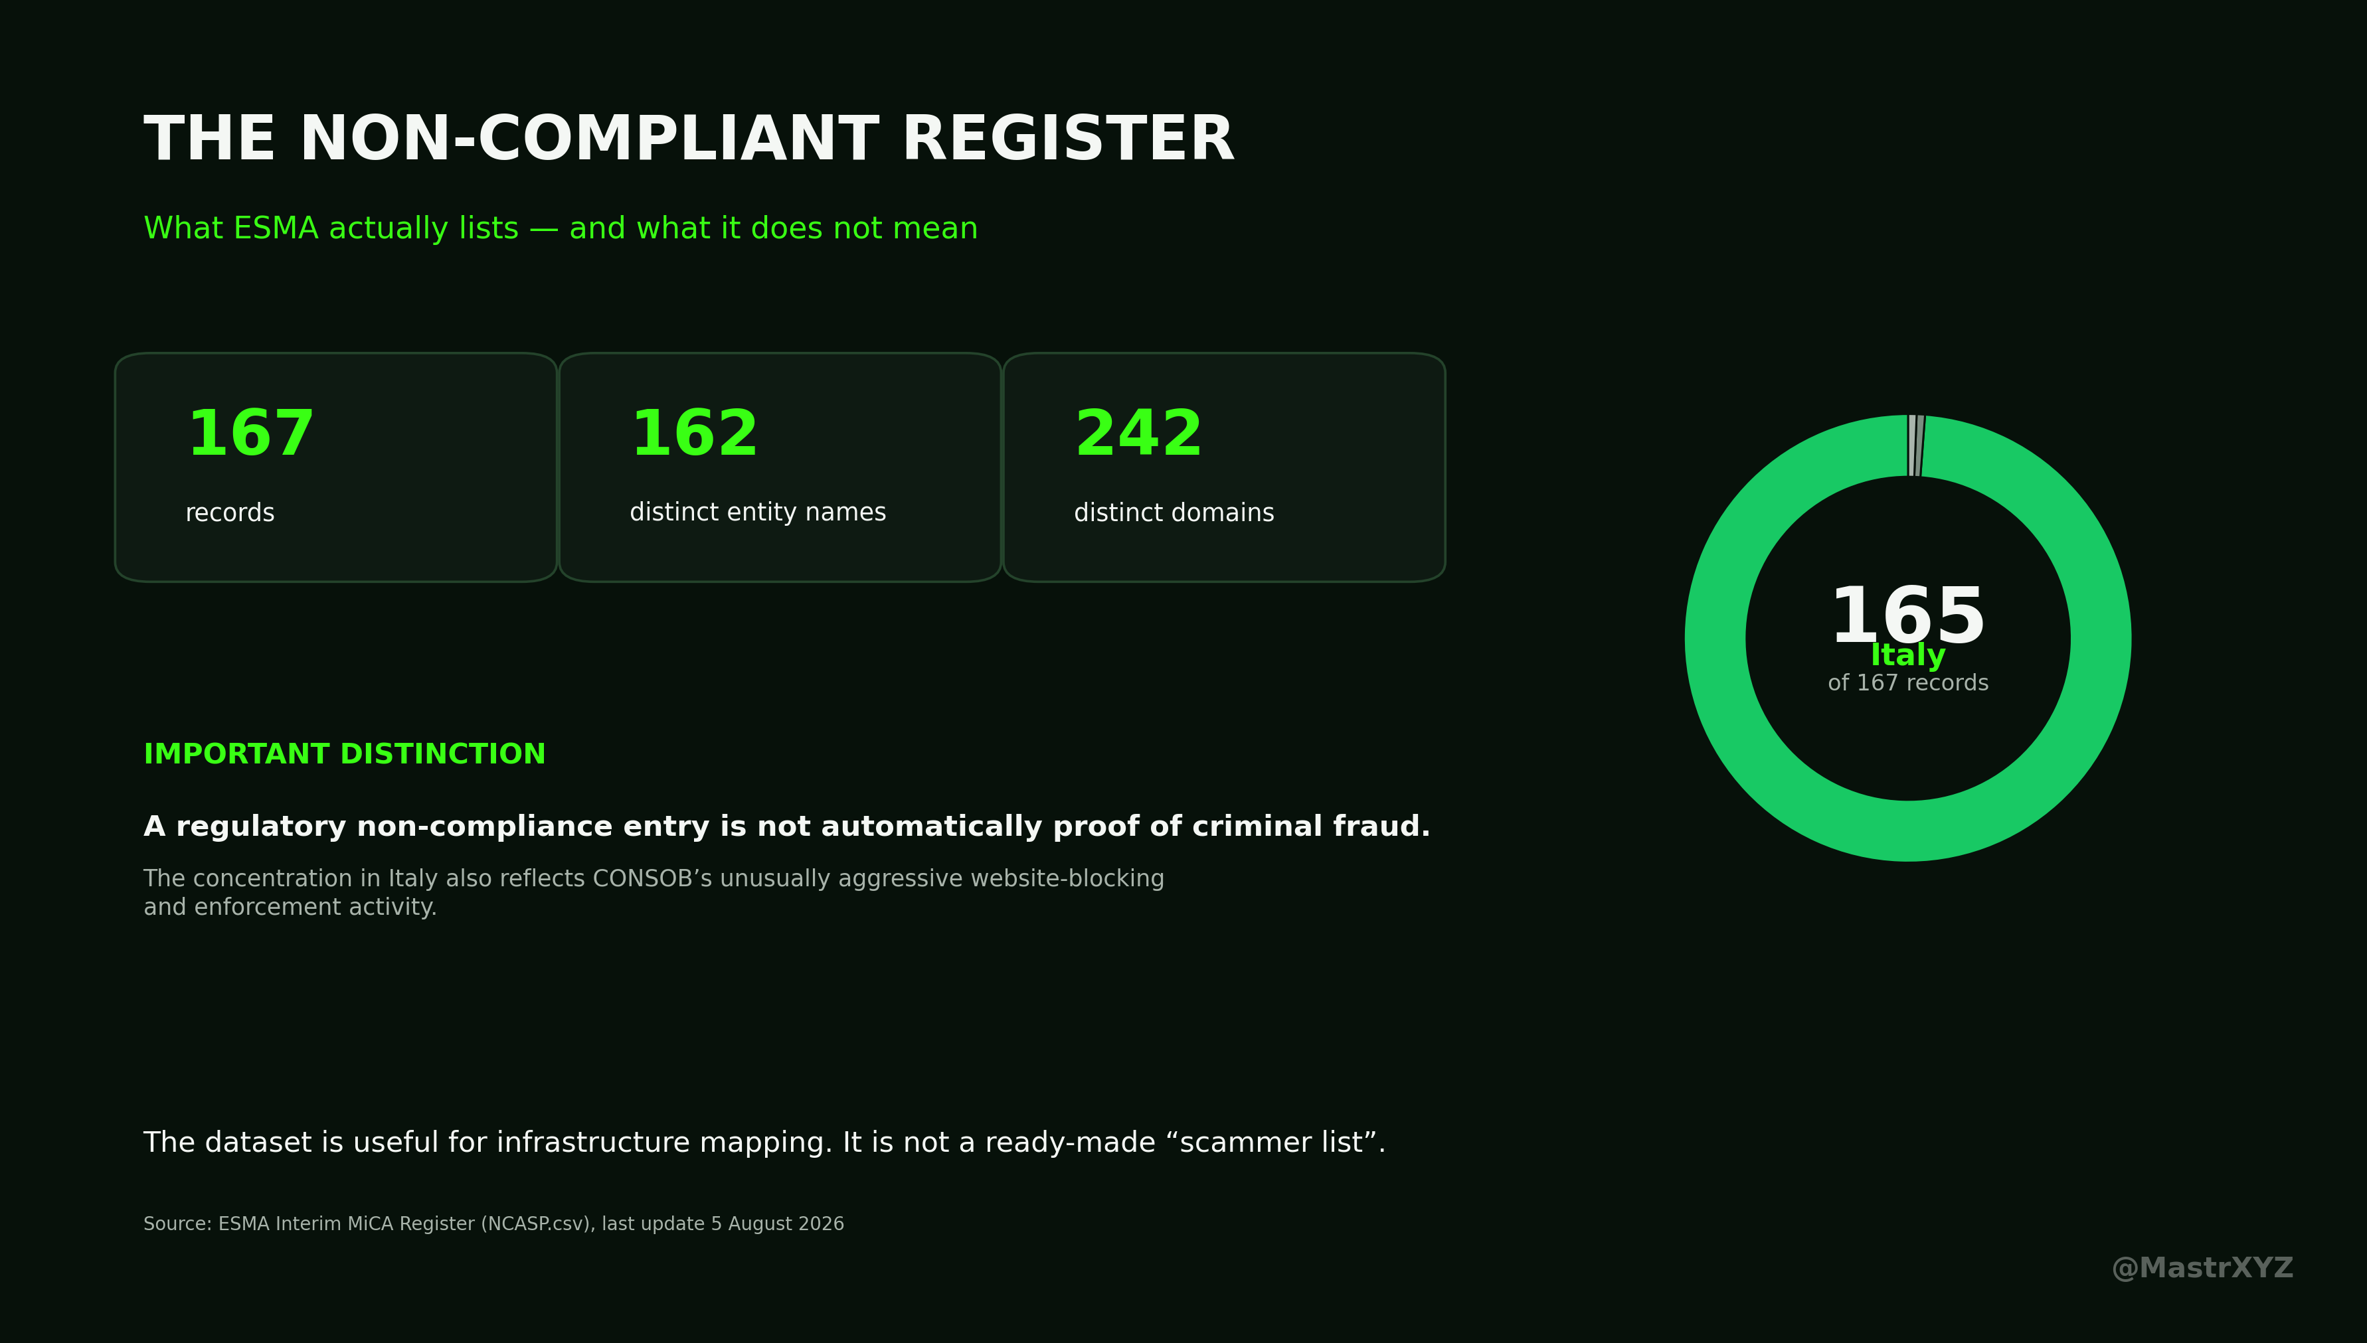
Data graphic • @MastrXYZ

Sources and methodology
Primary-register counts in this article were calculated directly from ESMA’s CASPS.csv and NCASP.csv files published on August 5, 2026. Domain counts were normalised by hostname. Regulatory non-compliance is not treated as proof of criminal fraud unless a source explicitly establishes fraud or identity theft.
1. ESMA — Markets in Crypto-Assets Regulation (MiCA), Interim Register, updated 5 Aug 2026
https://www.esma.europa.eu/esmas-activities/digital-finance-and-innovation/markets-crypto-assets-regulation-mica
2. MFSA — Crypto-Related Impersonation Scams During MiCA Transition, 7 Aug 2026
https://www.mfsa.mt/news-item/mfsa-notice-crypto-related-impersonation-scams-during-mica-transition/
3. Financial Times — Scammers pose as watchdogs to exploit EU crypto rule transition
https://www.ft.com/content/b0b7db1d-5c9e-42d7-8aed-176e0acd00a9
4. VASPnet — From 3,781 VASPs to 289 CASPs, 21 Jul 2026
https://vaspnet.com/articles/from-3-781-vasps-to-289-casps-what-mica-changed-in-europes-crypto-market
5. ESMA — Frauds and Scams related to ESMA Logo and ID
https://www.esma.europa.eu/investor-corner/frauds-and-scams
6. AMF — End of the MiCA transitional period, 23 Jun 2026
https://www.amf-france.org/en/news-publications/news/end-mica-transitional-period-esma-sets-out-its-expectations-professionals-and-warns-retail-investors
7. BaFin — onlinesparen.expert / onlinesparenglobal.com / ai-wallet.org identity theft warning, 7 Aug 2026
https://www.bafin.de/SharedDocs/Veroeffentlichungen/EN/Verbrauchermitteilung/unerlaubte/2026/meldung_2026_08_07_onlinesparen_onlinesparenglobal_en.html
8. CONSOB — Latest warnings / MiCA website blocking actions
https://www.consob.it/web/consob-and-its-activities/warnings/latests
9. Chainalysis — 2026 Crypto Crime Report: Scams, 13 Jan 2026
https://www.chainalysis.com/blog/crypto-scams-2026/
@MastrXYZ

